The European Chronicle

An interview with the King of Spain Philip II

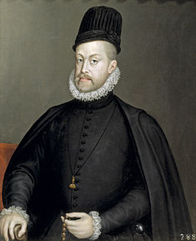 By: Max Alfano-Smith

Max Alfano-Smith: Now that the residents of the Netherlands have managed to achieve Independence from Spain, has your position changed on Protestants and do you feel that the departure of the Dutch is a major loss for the Spanish?

Philip II: Of course, I still can’t stand the Protestants; furthermore, their departure from our nation is great since it means that we can once again be a completely Christian nation.

Max Alfano-Smith: Given your loss of the Spanish Armada at the hands of the English, do you think going to war with them was the right decision for the Spanish?

King Philip II

Philip II: How dare you question my militaristic abilities? Even though we lost the Armada, attacking England was the right decision since it showed that I am the primary defender of a Catholic Europe.

Max Alfano-Smith: Do you think your hard policies on Protestants have helped the nation of Spain strengthen its foreign affairs?

Philip II: My strong position against the non-Christian nations of the world has greatly improved Spain’s standing in the eyes of glorious God.

Max Alfano-Smith: Given that you have caused Spain to default loans on four different occasions, would you say that it’s a fair assessment that you have done a bad job managing Spain’s finances?

Philip II: If I wanted a commoner’s opinion on economic policies, I would have asked. Furthermore, I took office with a national debt of 36 million ducats, so the assumption that this has all happened under my watch is ridiculous.

Max Alfano-Smith: Would you say that your reign has been successful, and what would you like the people of Spain to remember you as?

Philip II: A person would have to be blind and deaf to think that my reign has been unsuccessful, and in terms of what I want to be remembered for, all I wish for after my death is that people think of me as the defender of a Catholic Europe.